City of Parramatta

EXPRESSION OF INTEREST (EOI)
INFORMATION PACK

Heritage Advisory Committee

Closing Time and Date | 4:00pm, 20 November 2017
Contact Officer | Paul Kennedy  Project Officer Land Use Planning  City of Parramatta Council  PO Box 32  PARRAMATTA NSW 2124  Email: pkennedy@parracity.nsw.gov.au  9806 5093

Background

- The Heritage Advisory Committee’s purpose is advise Council on how best to conserve, promote and manage Parramatta’s heritage for future generations.

Role of the Committee

2. The Committee works with Council to:

- Advise Council on how to promote and involve the community in Parramatta’s heritage and history
- Encourage Council to support and endorse programs and events that promote heritage in Parramatta
- Share information about heritage events and issues in the City of Parramatta LGA
- Provide comment on development applications and proposals of heritage significance including archaeological investigations
- Make recommendations to Council on applications for the Local Heritage Fund
- Assist Council with the identification, protection and preservation of significant items of heritage
- Provide support on issues for the appropriate care and protection, including the ongoing management and stewardship, of items of heritage
- Support and encourage the acquisition and management of archival, oral and documentary evidence and environmental details for heritage items

- The Committee reports to Council through bi-monthly Council Reports.

Membership

4. Membership of the Heritage Advisory Committee is voluntary and includes:

- A minimum of (8) community members to a maximum of 14 members who have a founded commitment, sensitivity and understanding of heritage issues in the City of Parramatta LGA and in addition who should:
  - live, work, or study in the City of Parramatta LGA, and or
  - be an employee or member of an organisation whose primary function relates to the preservation of heritage.

In addition, the following are ex-officio members:

- Parramatta City Councillors
- Council staff from relevant departments (eg Development, Traffic and Transport).

5. Membership of the Heritage Advisory Committee is for a period of four (4) years to coincide with Council elections.

6. The Chair is elected by the Committee and shall not be a Councillor or Council staff member. The Chair is elected on an annual basis.
Meetings

7. Meetings of the Committee are held on a bi-monthly basis at various locations organised by Council staff and will be held in the early evening.

Selection Criteria

8. Applicants must have a proven commitment, sensitivity, and understanding of issues relating to heritage issues in the City of Parramatta LGA and should:

- live, work, or study in the City of Parramatta LGA, and or
- be an employee, or member of an organisation whose primary function relates to the preservation of heritage

EOI Submission

9. Council invites interested members of the community to submit an EOI to Council by 4:00pm, 20 November 2017.

10. All enquiries or requests for information should be directed to Paul Kennedy by email: pkennedy@parracity.nsw.gov.au, or by telephone: 9806 5093.

11. A panel of three (3) Council staff will assess EOIs against the selection criteria.

12. Recommendations for the appointment of the Heritage Advisory Committee will be made to Council in early 2018.

13. Requirements:

- Your Expression of Interest should comprise Attachment 1 completed

- Expressions of Interest should be clearly marked CONFIDENTIAL and addressed to:

Expression of Interest – Heritage Advisory Committee
Paul Kennedy
City of Parramatta Council

pkennedy@parracity.nsw.gov.au
(for email)

OR

PO Box 32
PARRAMATTA NSW 2124
(for post)

OR

Ground floor
126 Church Street
PARRAMATTA NSW 2150
(for submitting in person)

14. City of Parramatta Council boundaries

Below is both a map of the City of Parramatta LGA with Ward Boundaries, and a link to a webpage that can be enlarged for further details.

https://www.cityofparramatta.nsw.gov.au/council/governance-of-the-council/wards

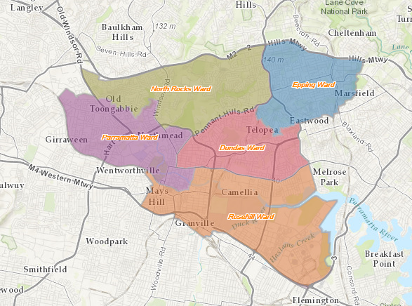

Attachment 1

CITY of PARRAMATTA COUNCIL

Expressions of Interest Form 2017 – Heritage Advisory Committee

I wish to be considered as a member of City of Parramatta Council’s Heritage Advisory Committee.
Name: ………………………………………………………………………………………………
Address: ……………………………………………………………………………………………
……………………………………………………………………………………………………….
Employer/Business Name: (if applicable) ………………………………………………………
Business Address: (if applicable) ……………………………………………………………….
……………………………………………………………………………………………………....
Phone: ……………………………… Mobile: ……………………………………………………
Email:…………………………………………………………………………………………….....

NB. Any persons, company or organisation contracting services to City of Parramatta Council may be precluded from being a member of the Committee.

Please tick the boxes that relate to you below:

1. I am
i. a resident of the City of Parramatta LGA □
ii. an employee, or member of an organisation responsible for the □
preservation of heritage.
iii. a worker in the City of Parramatta LGA □
iv. a student in the City of Parramatta LGA □
v. other □

If other, please provide brief details:
……………………………………………………………………………………………………....………………………………………………………………………………………………………………………………………………………………………………………………………………………………………………………………………………………………………………………………………………………………………………………………………………………………………………………………………………………………………………………………………

2. I have:
- personal experience in heritage issues □
- professional experience related to heritage issues □
- knowledge and a commitment to heritage issues □
- other □

Please provide brief details:
………………………………………………………………………………………………………………………………………………………………………………………………………………………………………………………………………………………………………………………………………………………………………………………………………………………………………………………………………………………………………………………………………………………………………………………………………………………………………………
3. I have:
i. experience as a member of the previous Heritage Advisory □
Committee
ii. experience in a similar position □

Please provide brief details:

………………………………………………………………………………………………………………………………………………………………………………………………………………………………………………………………………………………………………………………………………………………………………………………………………………………………………………………………………………………………………………………………………………………………………………………………………………………………………………

4. Please provide any other information that you feel may be relevant to Council’s consideration of your interest.
………………………………………………………………………………………………………………………………………………………………………………………………………………………………………………………………………………………………………………………………………………………………………………………………………………………………………………………………………………………………………………………………………………………………………………………………………………………………………………

5. I, the undersigned:

i. am committed to act in accordance with Council’s Code of Conduct □
ii. am committed to access and equity principles □
iii. have general acceptance of the communities I represent □

Signature: ………………………………… Date: ………………………..

Please attach any supporting documentation and submit your Expression of Interest by 4 PM, 20 November 2017.

